*SWE40001, Software Engineering Project, Semester 1, 5/04/2018*

Smart-glass based remote guidance system

Project Plan Document

Group 21  
 Lyndon Prado - 9740783  
 Tingcong Jimmy Li - 100017000  
 Keagan Foster - 101609822  
 Ayub Khan - 100667654  
 Dineth Gunawardena - 100862158  
 Kosala Edirisinghe - 101265981  
 Krishna Adhikari - 4953193  
 Liam Pan -101106174  
 Migara Gunarathne - 101002269  
 Shenal Nirushka – 101054998

**Table 1. Document Change Control**

|  |  |  |  |
| --- | --- | --- | --- |
| **Version** | **Date** | **Authors** | **Summary of Changes** |
| 1.0 | 15/04/2018 | All Authors | Initial draft created |
| 1.1 | 25/04/2018 | Keagan Foster | Updated based upon feedback from external reviews |
| 1.2 | 07/05/2018 | Keagan Foster | Updated based upon feedback from quality assurance review |
| 1.21 | 09/05/2018 | Liam Pan | Document Standards Review  Spelling and Grammar Review |
| 1.22 | 16/05/2018 | Keagan Foster | Updated based upon feedback from client meeting |

**Table 2. Document Sign Off**

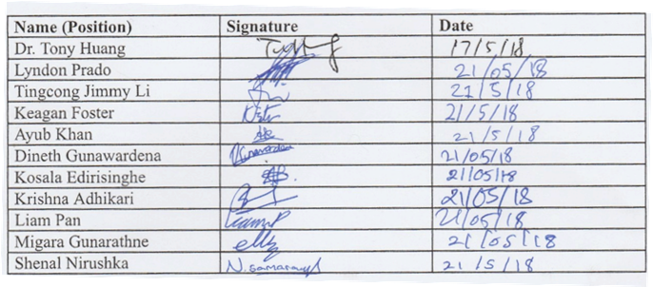

**Acronyms/Abbreviations**

**ASAP -** as soon as possible

**COB -** close of business (5pm)

**SGBRG -** Smart glass based remote guidance

**Smart Glass -** Vuzix M100 Smart Glasses

**Instructor -** Users who are giving instructions

**Operator -** Users who are receiving instructions

Table of Contents

**Introduction** **4**

Purpose of Document 4

Background 4

Key Project Personnel 4

Client 4

Stakeholders 4

Project Manager and Key Project Members 5

**Terms of Reference** **6**

Goals 6

Objectives 6

Scope 6

Critical Success Factors 6

Acceptance Criteria 7

**Establishment** **8**

Processes, Procedures and Standards 8

Project Environment 9

Project team training requirements 9

**Activities, Deliverables and Capital Resources** **11**

Deliverables 11

Activities and Tasks 12

Capital Resources 13

**Resources** **13**

Organisation and Structure 13

**Risks** **14**

**Schedule** **16**

Delivery Phases 16

Overview 16

Delivery Phase 1 - Live Streaming 17

Delivery Phase 2 - Hand Gestures 18

Delivery Phase 3 - Object recognition 18

Delivery Phase 4 - Meat quality & dimensions 18

External Dependencies 18

Assumptions 18

Project Timeline 19

**Budget** **21**

# Introduction

## Purpose of Document

This project plan is a formal document which has been designed to guide the control and execution of this project. It is the key to a successful project and is an important document that needs to be created when starting any business project which documents stakeholder products and project expectations, to control schedule and delivery and to calculate and manage risks.

## Background

Through the Swinburne Capstone Project Proposal Form, Dr. Tony Huang made his proposal to design and develop the smart-glass based remote guidance system. In this proposal, he describes the applications of the proposed system and the work required to research and develop it.

With the recent innovation of wearable technology, Dr. Tony Huang seeks to utilise this technology in industries around the world to aid in teaching of untrained users.

This project is using aspects of previous developed systems made by the CSIRO, and will only be a prototype to be used for research and demonstration of the concept. While the project is going to be designed for the meat industry, this system should be translatable to other industries as well.

## Key Project Personnel

### Client

The client for this project is Dr. Tony Huang of Swinburne University of Technology.

### Stakeholders

* CSIRO. Dr. Tony Huang is working in conjunction with CSIRO to help develop this system. CSIRO will have no role in communication with the development team, but may relay messages and information for the client to pass on.
* Prof. Jean-Guy Schneider. Prof. Schneider is the convener for SWE40001 and is associated with the success of the project. If serious issues arise that the development team cannot manage, Prof. Schneider may be forced to intervene and affect the state of the project.
* Prof. Jun Han. Prof. Jun Han is the supervisor of the team and will be assisting and overlooking progress made throughout the project. Jun will not have any direct communication with the client, but through meeting with the team he might alter the state of the project depending on the progress made.

### Project Manager and Key Project Members

* Lyndon Prado - Team Lead / Client Liaison
* Keagan Foster - Planning Manager / Team Lead
* Tingcong Jimmy Li - Development Manager / Team Lead
* Krishna Adhikari - Scrum Master / Team Lead
* Ayub Khan - Trello Manager
* Liam Pan - Documentation Manager
* Dineth Gunawardena - Developer
* Kosala Edirisinghe - Developer
* Miagara Gunarathne - Developer
* Shenal Nirushka - Developer

# Terms of Reference

## Goals

The goal of this project is to develop the first prototype of the Remote Guidance System on the Vuzix M100 Smart Glass running the Android System. The prototype will allow two users to communicate through video and enable the capture and transfer of hand gestures between the two users using a camera. The prototype will also be capable of object recognition, and users are able to use this feature to annotate over objects for later analysis, determine the dimensions and quality of a piece of meat and allow menu actions to be controlled by simple hand gestures. At the end of the project a video demonstration of this prototype will be created and given to the client.

## Objectives

* Live video stream between two smart glass users.
* Overlay hand gestures of one user onto the second user’s display.
* Object Recognition/Identification.
* Determine the quality and the dimensions of a piece of meat.
* Switch views of video streaming.
* Create a video demonstration of the system.
* Object annotation/sketching with finger (index finger).

## Scope

* The system will be designed for the meat industry.
* Some functionalities of the system (video streaming, hand gesture capture, switching video point of view, sketching) will be able to be transferred to other industries.
* The system will be developed on Android and then transferred onto the smart-glasses.
* The project does not have to include any http protocols to connect the two smart glasses, connection can be handled however the development team seems fit.
* The project will have a completed video demonstration, which illustrates the functionality of the prototype and its intended use.
* This system is a prototype intended for demonstration and research purposes, and therefore does not need to be market ready on completion.

## Critical Success Factors

* The system must display hand gestures fast enough so that the operator can understand the gestures made. This involves processing the instructor’s hands and displaying them to the operator so that the operator can receive accurate instructions. This can be measured through time tracking, usability testing. The client has specified that the speed must be under half a second for the gestures to be understandable.
* The system can identify specified hand gestures as commands and complete the appropriate action. The hand gestures will be used to control most menu interaction with the system, as well as some functionalities such as sketching and object recognition. This can be tested by accuracy of hand gesture identification, and usability testing.
* The system must be simple to use. As a characteristic of the intended user group is having little to or no prior experience with this type of technology, the system must be understandable and user friendly. This can be measured through usability testing with metrics such as number of errors, the amount of help required, time taken to complete tasks, etc.
* The system can identify a piece of meat, and correctly give its quality and dimensions to the operator. This is one of the requirements stated by the client and must be functional at the time of presentation. This can be measured by comparing results of image processing to the actual measurements and quality to test how accurate the system was.

## Acceptance Criteria

For the client to accept the completion of this project he will be assessing the major functionality of the system and reviewing all the critical success factors stated in section 2.4.

The conditions to determine an acceptable project are:

* Two user’s smart glasses can stream live video footage, captured by the smart glass, from one user to the other.
* The operator and instructor can switch the live video streaming from one’s perspective to the other.
* The instructor’s hands, separate from the background, will be streamed to the operator.
* Given a point of reference, the smart glass can display to the user the dimensions of a piece of meat.
* A user can sketch an image which is displayed to the other user.
* The system will have hand gestures displayed to the other user in less than one second after performing the gesture.

As the development team has chosen to follow the Scrum methodology, which is explained in greater details in section 3.1, the client will have monthly opportunities to review the functionalities created in that time. In this review, the development team will present all aspects of the functionalities that were created, which the client then has an opportunity to assess and give feedback on. It is at these reviews, and at the final presentation, where the client can state whether each item on the scope meets his standards or not.

# Establishment

## Processes, Procedures and Standards

As a team, we have decided to follow the Scrum methodology. Scrum is a lightweight Agile method used to help complete complex projects iteratively by using techniques to increase flexibility and productivity. Scrum breaks delivery into timeboxed iterations, called Sprints, and tracks progress daily through Stand-up meetings.

We chose the Scrum methodology due to multiple reasons that make it the best suited model for our team to work on this project:

* This methodology is a user-centred approach as it focuses on user stories, and therefore is acceptable for this project.
* Our client expects us to deliver multiple distinct major features (video streaming, device communication, hand gesture recognition, etc) which allows us to easily segments the project into Sprints.
* Using the Scrum method allows us to gain a feedback from our client, letting us focus on delivering the right features and allowing us to change early in the development and design stages of the project. This will mean that we can reduce the risk of costly late stage changes that require significant resources (time) to fix.
* As a team, using the Scrum model will allow us to better manage progress of the project and catch problems as they arise. This also gives our team opportunities to become managers for different sections and broaden our skills, while being able to test out what works for each individual in the team setting.

The Scrum will have 3 main sections in it.

* Sprint 0, which is the planning and organising section of the project
* Sprint 1-n, which are the individual sprints are taking place, which aim to complete a certain product backlog item in that time period and then present it to the client.
* Transition sprint, where the development team finalises the system and presents it to the client.

More information about our Software Development Life Cycle can be find in the SDLC plan.

The usability testing will occur in two stages, the informal and the formal testing. For our formal testing we will bring in untrained users in a controlled environment and ask them to complete a series of tasks in order to assess the successes and failures of the system. This will include user group forms, satisfaction forms and areas for feedback. This will be an iterative process that will be done multiple times throughout the project for different areas of the system. The informal testing will be done at every stage of this project by members of the team.

In the design stage of the project (Sprint 0), the Software Quality Assurance Plan will be created which outlines the policies and procedures that the development team will follow to achieve an overall high standard of quality. This document defines quality standards for the following aspects of the project:

* Management
* Documentation
* Development
* Reviews and audits
* Testing
* Problem reporting and corrective action
* Tools and methodologies
* Record collection, maintenance and retention
* Risk management

## Project Environment

* This system will require at least two smart-glasses for the instructor and operator.
* Two mobile phones may also be required to communicate with the glasses and with each other in case extra processing power is needed.
* There will be no Database Management System or accounts at this stage as no http protocols are being called upon.
* A single-coloured background or a pair of single-coloured gloves may be required to accurately capture hand gestures.
* For the later development, a surface with a meat product will be required to accurately test the functionality of grading the meat and finding its dimensions.
* A ruler or some other point of reference is required to find the dimensions of the meat.

## Project team training requirements

As the development team is not specialized in this field of study, training is required to help team members gain necessary knowledge related to this project. Training topics include:

* Usage of Git repositories
* Android development
* Usage of time tracking software and management software
* Usage of smart glasses
* Object recognition
* Object processing

This training will occur primarily before major development begins and as needed throughout the project, which will be facilitated by experienced team members teaching a specific area of understanding.

# Activities, Deliverables and Capital Resources

## Deliverables

* Working system. Features include:
  + Video live streaming of the operator’s point of view to the instructor and vice versa. This functionality will create the basis for which the system can be implemented on and therefore it is of highest priority. As visibility might become an issue due to screen size, some adjustments to the field of view might need to be made to improve understandability.
  + Capturing instructor’s hand movements and displaying it to the operator. This will allow the operator to view the instructor’s hand gestures placed upon operator’s point of view. As this system is intended for prototype purposes, the use of additional resources such as a solid colour background or hand wear can be used to aid in recognition, but preferably the system should be able to work without assistance. Ideally the system should be able to identify specified hand gestures and perform given actions.
  + Meat quality processing. This includes recognising the piece of meat, processing its quality through its colour and identifying its dimensions. Processing of this image should ideally be done on the given hardware if possible, however offloading processing to a mobile phone is acceptable. This will be used to demonstrate the additional functionality that can be added to this system for other industries to utilise.
  + Sketching functionality. This allows the instructor to signal to the system to begin a sketching, which starts by following his finger across the camera’s point of view, leaving his sketch on the screen. The instructor then has an option to either delete this sketch or send it to the operator to view.
* Project Plan to be handed over to the client before the beginning of the development, and to be continually updated throughout the project.
* Video showcase of the finalised system. This will be handed to the client at the end of the project for the purposes of demonstration at events. This is dependent on the project’s milestones being completed.
* Software Requirements Specification to be handed over to the client before the beginning of the development.
* Test Plan which tests all of the requirements stated in the Software Requirements Specification, and will be handed to the client before development.
* Software Quality Assurance Plan to be handed over to the client before the beginning of the development.
* Design Documentation to be shown and approved by the client before implementation begins.

## Activities and Tasks

**Semester 1 Sprints**

Sprint 0

* **Goal:** To gather as much information regarding project specifications, setup team structure and create all required documents
* **Activities:** 
  + Continual meeting with client to ensure the project is fully understood
  + Conduct team meetings to organise team and setup structure
  + Create Software Development Life Cycle Plan
  + Create Project Plan
  + Conduct architecture research
  + Setup development environment
  + Create Software Requirement Specification
  + Create Software Quality Assurance Plan
  + Create Testing Plan

Spike 1

* **Goal:** Setup device communication
* **Activities:** 
  + Research existing methods of connecting android devices
  + Implement chosen method
  + Test by sending data from one device to the other
* **Goal:** Achieve video streaming
* **Activities:**
  + Research existing libraries that provide live streaming functionality
  + Determine whether developing new code or using an existing library would work better for this project
  + Implement chosen method through developing and altering code and transferring it to the smart glasses
  + Test live streaming functionality
  + Discuss often with client if this holds up to their standards
* **Goal:** Switching video view point
* **Activities:** 
  + Using the chosen action, assign it to alter operator’s smart glasses screen to view instructor’s environment
  + Implement functionality
  + Test functionality of switching points of view
  + Discuss often with client if this holds up to their standards
* **Goal:** Create presentation video
  + Discuss key focus points in video
  + Storyboard plan the video
  + Gather video recording equipment and props
  + Film video segments
  + Edit video

**Semester 2 Sprint Goals**

* **Goal:** Hand gesture capture
* **Goal:** Hand gesture recognition
* **Goal:** Object recognition
* **Goal:** Annotating objects
* **Goal:** Meat quality processing
* **Goal:** Finalize project
* **Goal:** Final presentation video

## Capital Resources

* 2 Vuzix M100 Smart Glasses
* 10 Swinburne students

# Resources

## Organisation and Structure

* Dr. Tony Huang is the client for this project, who will provide details and specifications regarding the functionality and overall scope of this project. He and the project team will meet regularly to discuss details about the project and clarify any understandings about the project. At the end of the project, he will assess whether the project is satisfactory to what he requested and therefore if the project was a success.
* There will be a number of Testers for the project, who we will contact and use in regards to usability testing. According to feedback from them (alongside the Client), we may need to make changes to the system in order to make it more convenient to use. The Testers will be contacted throughout the project as the team makes progress in order to make sure that the program does not run into any major problems.

# Risks

**Table 3. Complete risk assessment**

|  |  |  |  |  |  |
| --- | --- | --- | --- | --- | --- |
| **Rank** | **Name / description** | **Occurrence Probability**  **(H/M/L)** | **Severity**  **(H/M/L)** | **Mitigation Strategy** | **Contingency** |
| 1 | Time shortage | H | H | Rigorous design methodology prior to development including work distribution and conservative timelines. | Reduce complexity and range of tasks and focus on the core functionality of the system. |
| 2 | Design Errors | H | H | Rigorous design methodology prior to development. | Pivot the design of system using new found information |
| 3 | Design lacks flexibility | M | H | When designing system allow room to change design in case specifications change | Pivot the design by altering it to better suit the clients requirements |
| 4 | Changing client requirements | M | M | Rigorous discussion of requirements plus official SRS document early in project timeline. | Pivot design to better suit the clients requirements |
| 5 | Lack of knowledge | M | M | Identify skill level of team members and any gaps before development begins and provide training | Provide training to unskilled team members to bring them up to speed with development |
| 6 | Training is inadequate | M | M | Create training schedule and program, with the best suited teacher available | Organise more sessions until skill level is adequate or reassign capable team members |
| 7 | Dependencies are inaccurate | M | M | Utilize multiple team members when designing the schedule for best chances at understanding all dependencies | Alter schedule so that the project carries on being productive |
| 8 | Client unavailable | M | M | Vital questions for client to be communicated before they become critical | Attempt to communicate key questions over email and organise new meeting as soon as possible |
| 9 | Estimates are inaccurate | M | M | Using prior knowledge and estimating skills with multiple team members, work through all tasks allowing for overestimation | Using new knowledge on task length, alter estimates and determine if the scope of tasks is still doable |
| 10 | Under communication | M | M | Setup multiple methods of communication and points of contact | Re-evaluate communication methods and define actions to all team members |
| 11 | Client abandons project | L | H | Get as many modules and requirements off the client as possible | Use existing knowledge to design the system with requirements already extracted |
| 12 | Team member leaves | L | H | None. | Distribute work to other group members evenly |
| 13 | Illness or absence of team members | M | L | Shared understanding of work allows load to be distributed. | Distribute work to other group members evenly |
| 14 | Corruption of repository | L | H | Weekly backups plus local checkouts reduce impact significantly. | Utilise weekly backups to restore repository and re-upload individual commits |
| 15 | Hardware isn't adequate | L | H | Research capabilities of given hardware in advance to determine if any issues will arise | Determine what functions cannot be done on given hardware and pivot design to change functionality or get new hardware |

# Schedule

## Delivery Phases

### Overview

**Semester 1**

Sprint 0

* Delivery Date: 30th April 2017
* Includes: Project Plan,
  + Software Quality Assurance Plan
  + Software Requirement Specifications
  + Testing Plan
  + Client agreement form
* Sprint 0 is planned to take the longest amount of time in order to allow for the best possible understanding and design of this system before any development occurs. During this sprint, multiple meetings with the client are conducted to gain a strong idea of the requirements, as well as time to document all information about the project to create a joined understanding of what is expected to be delivered.

Spike 1

* Delivery Date: 26th May 2018
* Includes: Video live streaming from connected smart-glasses
* This spike is concerned with getting the major functionality of video live streaming functional. As this is a spike, it concerns itself with a user story that cannot be estimated until the development team runs a timeboxed investigation and will focus on researching and developing video live streaming between devices. During this time period, the development team will also be completing multiple external requirements that have been assigned to them by Swinburne University.

**Semester 2**

Sprint 1

* Delivery Date: 21th August 2018
* Includes: Ability to switch which user is video streaming their environment, video live streaming
* Sprint 1 is going to be the first properly run and organised sprint of this project, tackling a relatively easy product backlog item so that the development team can get more comfortable following coding standards and following quality checks. This sprint also brings all code and documentation from the previous spike up to the quality standards, as well as completing any delayed work from the spike.

Sprint 2

* Delivery Date: 10th September 2018
* Includes: Hand gesture streaming, hand gesture recognition
* Sprint 2 is taking the hand gesture streaming item from the product backlog, which involves segmenting the instructor’s hands from the background, tracking fingers and implementing gesture control functions.

Sprint 3

* Delivery Date: 1st October 2018
* Includes: Implement object identification
* Sprint 3 is working on object identification functionality, which is required for the future sprints. This involves implementing machine learning, gathering training data and model training.

Sprint 4

* Delivery Date: 28th October 2018
* Includes: Meat quality and dimensions, Image sketching
* This is the final sprint which implements meat quality and dimensions functionalities and image sketching. Using a specified user action, the image sketching will trace a finger and the meat quality processing will use a point of reference to identify a piece of meat to find its quality and dimensions.

### Delivery Phase 1 - Live Streaming

Requirements

* Devices must be available to be tested upon
* All documentation is completed

Deliverables

* Device Communication
* Video Live Streaming
* Point of view switching

Issues Resolved

* [To be filled in once delivery phase is complete]

### Delivery Phase 2 - Hand Gestures

Requirements

* Live streaming functionality added

Deliverables

* Instructor’s hand streamed
* Hand gesture recognition
* Device actions controlled by specified hand gestures

Issues Resolved

* [To be filled in once delivery phase is complete]

### Delivery Phase 3 - Object recognition

Requirements

* Live streaming functionality added

Deliverables

* Learnt objects recognised by smart-glasses

Issues Resolved

* [To be filled in once delivery phase is complete]

### Delivery Phase 4 - Meat quality & dimensions

Requirements

* Object recognition functionality added

Deliverables

* Meat Dimensions displayed to operator
* Meat Quality displayed to operator

Issues Resolved

* [To be filled in once delivery phase is complete]

## External Dependencies

* Verifying Requirement document with client and supervisor.
* Getting supervisor's approval on project plan.
* Selecting suitable applicants who belong to the user group of the product for usability testing of the software.
* Validating expectations of users by meeting their requirements.

## Assumptions

* Scheduling Accuracy- All deliverables will be completed and submitted on time.
* Human Resource Availability- All team members will have the budgeted time available to spend working on this project. Also, both the client and supervisor will have time to regularly meet with the development team to discuss progress.
* Client will provide the team with all the necessary equipment and goods. (Access to Vuzix M100 glasses and SDK)

## Project Timeline

**Image 1. Project Overview Gantt Chart for Semester 1**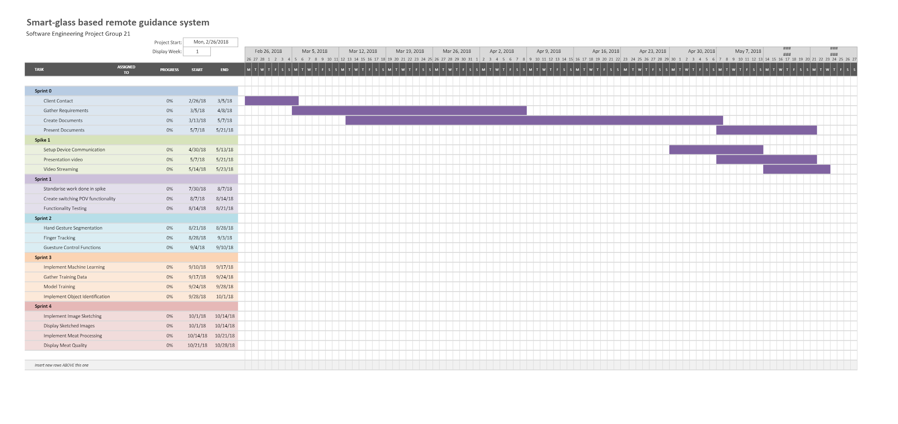

**Image 2. Project Overview Gantt Chart for Semester 2**

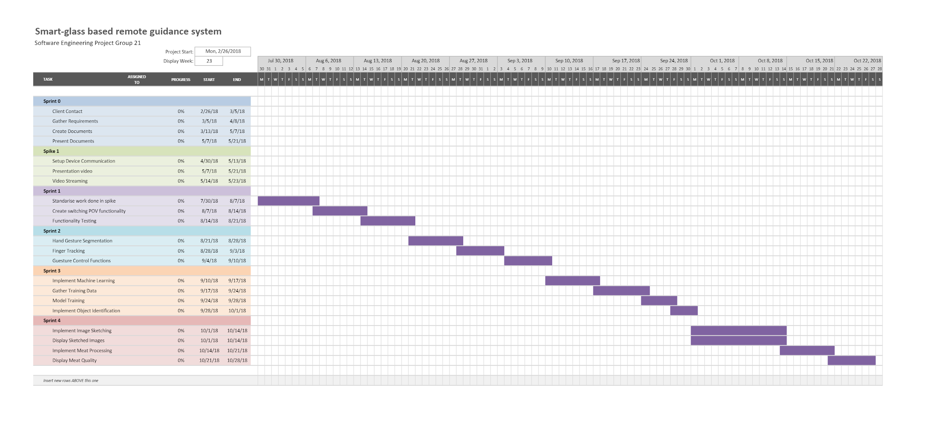

# Budget

**Table 4. Semester 1 Time Estimation (Delivery Phases)**

|  |  |  |  |  |
| --- | --- | --- | --- | --- |
|  | **Sprint 0** | | **Sprint 1** | |
|  | **Budget** | **Actual** | **Budget** | **Actual** |
| Team Leader | 70 |  | 40 |  |
| Planning Manager | 70 |  | 40 |  |
| Development Manager | 70 |  | 40 |  |
| Scrum Master | 70 |  | 40 |  |
| Documentation Manager | 70 |  | 40 |  |
| Developer (x5) | 70 |  | 40 |  |
| Total Labour Expense | 700h |  | 400h |  |

**Table 5. Semester 1 Time Estimation (Months)**

|  |  |  |  |  |  |  |
| --- | --- | --- | --- | --- | --- | --- |
|  | **March** | | **April** | | **May** | |
|  | **Budget** | **Actual** | **Budget** | **Actual** | **Budget** | **Actual** |
| Team Leader | 36 |  | 36 |  | 38 |  |
| Planning Manager | 36 |  | 36 |  | 38 |  |
| Development Manager | 36 |  | 36 |  | 38 |  |
| Scrum Master | 36 |  | 36 |  | 38 |  |
| Documentation Manager | 36 |  | 36 |  | 38 |  |
| Developer (x5) | 36 |  | 36 |  | 38 |  |
| Total Labour Expense | 360h |  | 360h |  | 380h |  |

**Table 6. Semester 2 Time Estimation (Delivery Phases)**

|  |  |  |  |  |  |  |  |  |
| --- | --- | --- | --- | --- | --- | --- | --- | --- |
|  | **Sprint 1** | | **Sprint 2** | | **Sprint 3** | | **Sprint 4** | |
|  | **Budget** | **Actual** | **Budget** | **Actual** | **Budget** | **Actual** | **Budget** | **Actual** |
| Team Leader | 30 |  | 32 |  | 30 |  | 40 |  |
| Planning Manager | 30 |  | 32 |  | 30 |  | 40 |  |
| Development Manager | 30 |  | 32 |  | 30 |  | 40 |  |
| Scrum Master | 30 |  | 32 |  | 30 |  | 40 |  |
| Documentation Manager | 30 |  | 32 |  | 30 |  | 40 |  |
| Developer (x5) | 30 |  | 32 |  | 30 |  | 40 |  |
| Total Labour Expense | 300h |  | 320h |  | 300h |  | 400h |  |

**Table 7. Semester 2 Time Estimation (Months)**

|  |  |  |  |  |  |  |
| --- | --- | --- | --- | --- | --- | --- |
|  | **August** | | **September** | | **October** | |
|  | **Budget** | **Actual** | **Budget** | **Actual** | **Budget** | **Actual** |
| Team Leader | 46 |  | 40 |  | 46 |  |
| Planning Manager | 46 |  | 40 |  | 46 |  |
| Development Manager | 46 |  | 40 |  | 46 |  |
| Scrum Master | 46 |  | 40 |  | 46 |  |
| Documentation Manager | 46 |  | 40 |  | 46 |  |
| Developer (x5) | 46 |  | 40 |  | 46 |  |
| Total Labour Expense | 460h |  | 400h |  | 460h |  |